Video Activity 1
- a baby
- a road
- clouds
- acrobats

Video Activity 2
1 Easy, difficult, exciting, boring .
2 Hungry, thirsty , tired.
3 Afraid, frightened, dangerous , surprised.
4 Hungry, thirsty, tired .

Video Activity 3
I think your mother's | more surprised than me.
Listen to this: | the family want to be in Diversicus, the circus.
Jumping and catching | are dangerous.
We've got the brilliant, | the brave Cameron Cat!

Video Activity 4
1. | The email came this morning.
2. | We’ve got the jobs. We’ve got the jobs.
3. | Let’s all go on an adventure!
4. | A world tour! A world tour!
5. | Let’s get busy. There’s a lot to do.
6. | Text our family. Email our friends.
7. | Let’s get busy. There’s a lot to do.
8. | Let’s get our books for the circus school.

Video Activity 5
- Australia.
- Europe.

Vocabulary 1
- surprised
- frightened
- dangerous
- hungry
- easy
- exciting
- difficult
- thirsty
- tired

Vocabulary 2
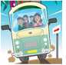
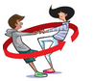

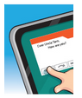
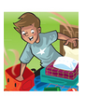
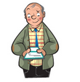
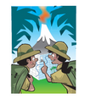

Grammar 1

1 The film I saw yesterday was amazing! It was more interesting than the film I saw last week.
2 Riding a bike is more difficult than walking. I often fall off!
3 I love animals! I think animals are more beautiful than paintings.
4 I'm very afraid of spiders. I think they're more frightening than lions!
5 Tigers are more dangerous than sheep.

Grammar 2
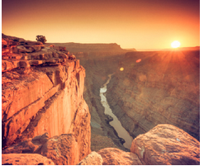 | I think the Grand Canyon is the most beautiful place in the world.
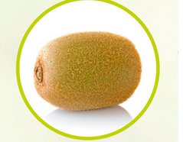 | I think kiwis are the most delicious fruit.
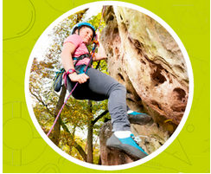 | I think climbing is the most exciting sport.
 | I think the roads are the most dangerous thing in my town.
Skills

- It was huge, black and very beautiful.
- It was the best weekend of my life, but also the coldest!
- It was a pet parrot so we were very happy and surprised!

