Video Activity 1
Watch the video. Which food don't you see?

- salad
- pasta
- lemonade
- potatoes
- pizza

Video Activity 2
Watch the video. Say the chant, then match the sentence halves.

soup. plate. glass. sandwich.

Cheese, pasta,
Salad, vegetables,
Bowl, bottle,
Cup and

Video Activity 3
Watch the video. Put the sentences in the correct order.

They got vegetables for us!
Mr Friendly went to Jim and Jenny's classroom.
My favourite kind of soup is sock soup!
They made a pasta salad.

1.
2.
3.
4.

Video Activity 4
Watch the video. Sing the song, then put the lyrics in order.

I’m boiling the pasta.
I’m frying the fish.
I’m starting the dinner.
Can you try this?

Wash the glasses.
Carry the plates.
Don’t drop the bowl!
We mustn’t be late.

Mum, stop crying.
Mum, don’t cry.
I’m cutting the onions.
It’s all right.

1.

2.

3.

Video Activity 5
Watch the video. Complete the sentences.

- We make paper from trees / cotton plants / seeds .
- We eat the flower / seeds / leaves of the lettuce plant.

Vocabulary 1
Look, read and choose.

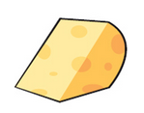  - T  - F | 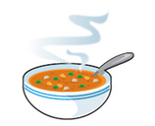  - T  - F |   - T  - F
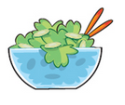  - T  - F |   - T  - F |   - T  - F
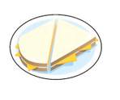  - T  - F | 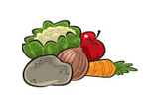  - T  - F | 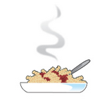  - T  - F

Vocabulary 2
Look, read and match.

boil carry cook drop cut
cry fry wash

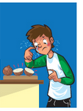 |  | 
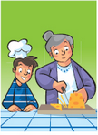 |  | 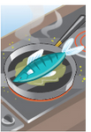
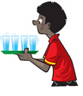 |  | 
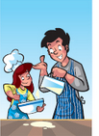 |  | 

Grammar 1
Look, read and match.
I ate cheese for dinner. I didn't eat salad.

I had coffee yesterday. I didn't have lemonade.

I ate hamburgers for lunch. I didn't eat a sandwich.

I had rice yesterday. I didn't have chicken.


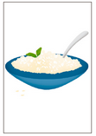
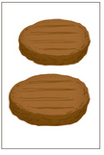
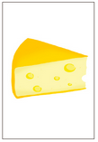

Grammar 2
Look, read and choose.
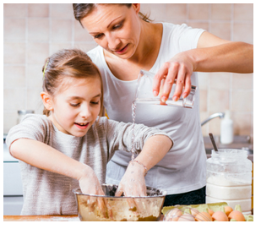

1 Yesterday, I help / helped my mum.
2 I cooked / cook dinner with her.
3 I fried / fry some eggs.
4 I boil / boiled some potatoes.
5 I wash / washed the carrots, too.

Skills
Read the texts. Choose the best topic sentence for each one.
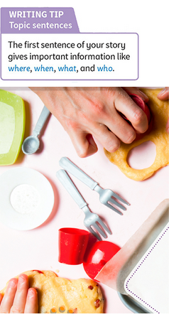
My dad is a cook and last Monday he made a big chocolate cake.
Last week, I went for a picnic.
Last week I wanted to make a sandwich.

1 ______________
First, we walked through a forest and up a mountain. Then, at 12 o'clock it started to rain. Everything got wet - me, my clothes, and all of the food. It was a very wet picnic!
2 ______________
I cut some tomatoes, cheese and salad, and put it in a bowl. But then I looked in the cupboard, and saw that there wasn't any bread!
3 ______________
But at the restaurant, no one wanted cake on Monday. They didn't want it on Tuesday or Wednesday either. So on Wednesday, in the evening, my dad brought home the cake for my mum, me and my cousins to eat. It was great!

