**Video Activity 1**

Watch the video. Which four things can you see?

|  |  |
| --- | --- |
| * a rainbow * snow * a lake * umbrellas * a kite |  |

**Video Activity 2**

Watch the video. Say the chant, then complete the sentences.

|  |  |
| --- | --- |
| 1 Hot, cold, sun, sunny / windy / cloudy.  2 Wind, sunny / windy / cloudy , cloud, cloudy.  3 Snow, it's snowing, sun / rainbow / rain , it's raining.  4 I can see a rainbow / snow / cloud. |  |

**Video Activity 3**

Watch the video. Match the sentence halves.

|  |  |
| --- | --- |
| those grey clouds. in the mountains.  but we weren't cold. Friendly today? |  |

|  |  |
| --- | --- |
| Look at |  |
| Where's Farmer |  |
| He was |  |
| We were in the snow, |  |

**Video Activity 4**

Watch the video. Sing the song, then match the clothes to the weather.

|  |  |
| --- | --- |
| scarf shorts sweater boots t-shirt coat |  |

|  |  |  |
| --- | --- | --- |
| It's hot and sunny | It's cold and windy | It's snowing |
|  |  |  |

**Video Activity 5**

Watch the video. Answer the questions.

|  |  |
| --- | --- |
| 1 Scientists measure how hot or cold it is with a ...   * thermometer * rain gauge * weather vane .   2 Scientists measure the direction of the wind with a ...   * thermometer * rain gauge * weather vane . |  |

**Vocabulary 1**

Look, read and choose.

|  |  |  |  |
| --- | --- | --- | --- |
| * sunny * cold | * rain * snow | * sunny * wind | * hot * cloud |
| * rainbow * cold | * wind * snow | * rain * hot | * rainbow * wind |

**Vocabulary 2**

Look, read and match.

|  |  |  |
| --- | --- | --- |
|  |  |  |
|  |  |  |

|  |  |  |  |
| --- | --- | --- | --- |
|  |  |  |  |
|  |  |  |  |
|  |  |  |  |

**Grammar 1**

Look, read and choose.

1 Yesterday  is / was great.

2 Mum and Dad wasn’t / weren’t at home, but I was!

3 There was / were a great film on TV.

4 The film was / weren’t  about a party.

5 At the party, there were / are  lots of clowns.

6 The film was / were very funny!

**Grammar 2**

Look, read and choose.

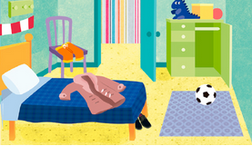

1 Was there a football in the bedroom?

* Yes, there was.
* No, there wasn't.

2 Were there any boots in the bedroom?

* Yes, there were.
* No, there weren't.

3 Were there any books in the bedroom?

* Yes, there were.
* No, there weren't.

4 Was there a scarf in the bedroom?

* Yes, there was.
* No, there wasn't.

**Skills**

Read the texts. Choose the best title for each one.

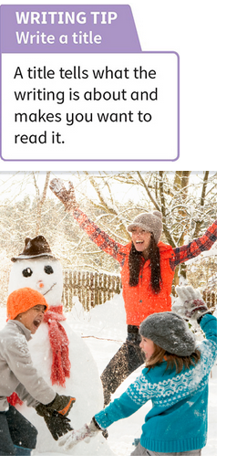

|  |
| --- |
| The weather  My favourite place  My family |

1  ______________________

Can you see my mum and my sister in this photo? I'm in the photo too. I'm wearing an orange hat. The man you can see isn't my dad. It's a snowman!  
2 ______________________

Where I live, it often snows and rains. I love snowy and sunny weather but I don't like rain!  
3 ______________________

I love my school and my house. But the place I like most is my garden. I often go there to play with my family. We often play football or build snowmen there.