**Video Activity 1**

* brown

**Video Activity 2**

1 Panda, whale, bat and bear.

2 Parrot, lion, penguin.

3 Panda, whale, bat and bear.

4 Kangeroo, rabbit, dolphin.

**Video Activity 3**

1. parrot
2. tail
3. Harry
4. Henrietta

**Video Activity 4**

1We’re all moving like wild animals.

2 It's losing its banana!

3 It’s falling in the sky!

4 He’s walking like a penguin.

**Video Activity 5**

|  |  |
| --- | --- |
| Camels, horses and elephants are | herbivores |
| Whales, sharks and tigers are | carnivores |
| Dogs, bears and people are | omnivores |

**Vocabulary 1**

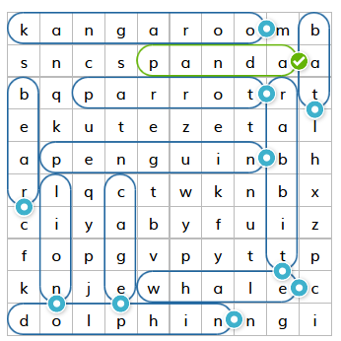F

**Vocabulary 2**

1. 
2. 
3. 
4. 
5. 
6. 
7. 
8. 

**Grammar 1**

1 My rabbit is the quickest of my pets.

2 My cousin is the youngest person in my family.

3 My mum is the prettiest person in my house.

4 I think bananas are the best fruit.

**Grammar 2**

1 The bat's above the tree.

2 The parrot's near the cage.

3 The snail's below the flower.

4 The bus stop's opposite the zoo.

**Skills**

1 Penguins can swim  but they can't fly.  
2 Penguins are black and white.  
3 Penguins' legs and wings are short.  
4 Penguins eat fish but they don't eat plants.