Video Activity 1
- a lift

Video Activity 2
Aunt, uncle, | cousin.
Parents, daughter, | son.
Granddaughter, grandson, | grandparents, grown-ups.

Video Activity 3
1. | Oh, Rocky, you are naughty!
2. | I'm bigger than my cousin, but she's got curlier hair than me.
3. | My ears are longer than your ears.
4. | We must all be nicer to everyone.

Video Activity 4
1. | Town centre, in the town centre, town centre.  Our Uncle Paul lives on the third floor.
2. | His flat’s got a balcony and a green door.  There are plants on his balcony and a garden on the roof.
3. | His car’s in the basement  and his guitar’s in his room.
4. | There’s a lift that goes up and down.  To his flat in the centre of town.

Video Activity 5
1 We use washing machines to clean our clothes.
2 A computer is a complex machine.

Vocabulary 1
- T
- T
- F
- T
- F
- T
- T
- T
- F

Vocabulary 2
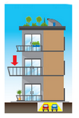 | balcony | 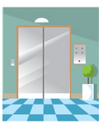 | lift
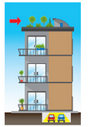 | roof | 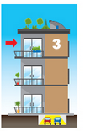 | third floor
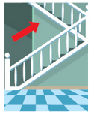 | upstairs | 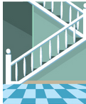 | stairs
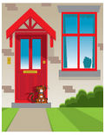 | outside | 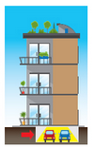 | basement

Grammar 1
1 My brother is taller than my sister.
2 My dad's hair is longer than my mum's hair.
3 My mum's hair is curlier than my aunt's hair.
4 My uncle is older than my dad.
Grammar 2
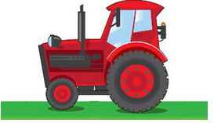  Is this your parents' tractor? | Yes, it's theirs.
  Is this your toothpaste? | Yes, it's mine.
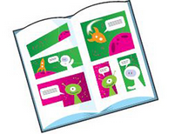  Is this your sister's comic? | Yes, it's hers.
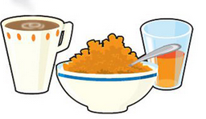  Is this your dad's breakfast? | Yes, it's his.

Skills
Nouns | Adjectives
email  camera  photos | red  small  great

