Video Activity 1
Watch the video. Which four things can you see?

- hats
- balloons
- presents
- sandwiches
- cake

Video Activity 2
Watch the video. Say the chant, then complete the sentences.

1 Grandpa Friendly is a cook / farmer / dentist .
2 Jim is a pirate / present / doctor.
3Jenny is a clown / pop star / film star.
4 Mrs Friendly is a doctor / dentist / nurse .

Video Activity 3
Watch the video. Match the sentence halves.

I'm wearing He's outside Film stars Doctors
I'm a pirate. Please

stop.
a clown costume, from the party.
help other people.
feeding the cows.
often go to parties.

Video Activity 4
Watch the video. Sing the song, then match the words with the scarecrows.

ugly straight hair curly hair thin fat

a moustache short purple nose tall

Eva's scarecrow | Tom's scarecrow | Jim and Jenny's scarecrow

Video Activity 5
Watch the video. Answer the questions.

- Teachers work ...
- in hospitals
- in kitchens
- in schools
- on farms.
- Cooks work ...
- in hospitals
- in kitchens
- in schools
- on farms.

Vocabulary 1
Look, read and choose.
- 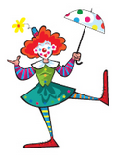  - pirate  - clown | -   - farmer  - doctor | - 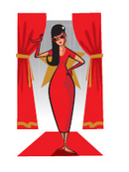  - film star  - cook
- 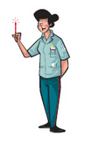  - nurse  - pop star | -   - film star  - dentist | - 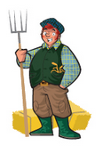  - farmer  - clown
- 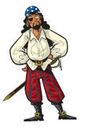  - nurse  - pirate | - 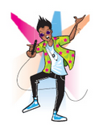  - pop star  - dentist | - 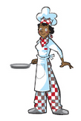  - doctor  - cook

Vocabulary 2
Look, read and match.

He's short and thin. He's got a big blonde moustache.
He's short and fat. He's got straight black hair.
He's tall and fat. He's got long fair hair.
He's tall and thin. He's got curly hair and a long beard.

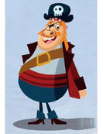
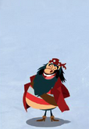
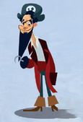
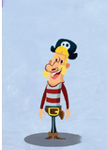

Grammar 1
Look, read and choose.
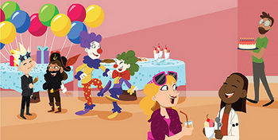

1 Today, I'm wear / wearing a clown costume.
2 I don't usually wear / wearing clown clothes, but today is my friend's birthday party.
3 I often go / going to parties.
4 When I go to parties, I always giving / give my friends presents.
5 I'm dance / dancing with my friend now.

Grammar 2
Look, read and answer the questions.

Because they're going to a party. Because he wants to cook dinner.
Because she's riding a bike. Because he loves stories.

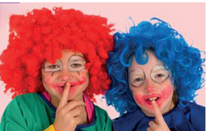
Why are they wearing costumes?
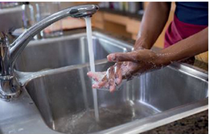
Why is he washing his hands?

Why is he reading a big book?
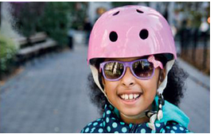
Why is she wearing a helmet?

Skills
Match the sentence halves.
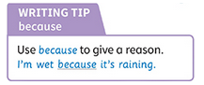

because I like dressing up. because it's raining.
because they're dirty. because I'm riding my bike.

I'm wearing a clown costume
I'm wearing a helmet
I'm washing my hands
I'm wet

