Video Activity 1
- a dog

Video Activity 2
Countryside, countryside, | forest and field.
Grass on the ground | and leaves on the trees.
Mountains and rocks, | rivers and lakes.

Video Activity 3
1. | The farm cat's got some babies.
2. | They can't open their eyes because they're very young!
3. | The one with the short tail's playing with a ball.
4. | It's eating Grandpa's old red sock.

Video Activity 4
1. | Wake up, get up.  Go and have a shower.
2. | Wake up, get up  Time for us to run!
3. | Get your towel, get dry.  Now go and get dressed.
4. | Get your towel, get dry.  Time for us to run!
5. | Sit down for breakfast.  Milk or juice for you?
6. | Sit down for breakfast.  Time for us to run!

Video Activity 5
1 There are eight planets that go round our sun.
2 Plastic is bad for animals that live in the sea.

Vocabulary 1
- T
- F
- T
- T
- T
- F
- F
- T
- T

Vocabulary 2
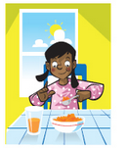 | have breakfast | 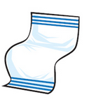 | towel
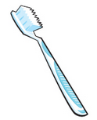 | toothbrush | 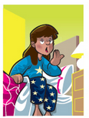 | get up
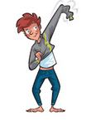 | get dressed |  | have a shower
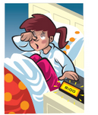 | wake up |  | toothpaste
Grammar 1
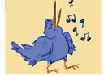 | The bird is singing.
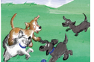 | The puppies are playing.
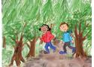 | The children are walking in the forest.
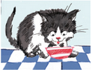 | The kitten is drinking some milk.
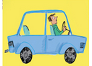 | The man is driving a car.

Grammar 2
1. | I have lunch at one o'clock.
2. | I go home from school at three o'clock.
3. | I play with my puppy at four o'clock.
4. | I have dinner at six o'clock.
5. | I do my homework at seven o'clock.
6. | I brush my teeth and go to bed at eight o'clock.

Skills
Hello!

My name's Clara. I'm eight years old. How old are you ?

What's your daily routine?
I get up at 7 o'clock and I go to school at eight o'clock. Then, I go home at four o'clock and go to bed at nine o'clock .
Love
Clara

